STA Coding Challenge – Web

Introduction
As part of our selection process for the role of Senior Test Analyst, you are required to build a test automation framework with some tests based on the TfL website – Journey Planner widget which is at https://tfl.gov.uk/plan-a-journey .
Please submit the completed challenge in 5 working days for us to review.

Instructions
- Write your tests in C#.
- Write your tests using gherkin syntax.
- Use “Playwright” and “Chromedriver” dotnet (.NET) libraries for UI Automation.
- Once complete, your code should be submitted to a public GIT repository such as a GitHub for us to review.
- Include a README file to talk about some of the development decisions you made.
- Use of AI: Responsible use of AI, add a disclaimer in README file if you have used AI to write any piece of code.

Overview of the TfL Website under Test
The website has a lot of functionalities as can be expected, however for the purpose of this challenge, we’ll only be focussing on the “Plan a journey” widget also known as “Journey Planner”.
The widget (screenshot below) is accessible from the TFL Homepage or by clicking the “Plan a journey” tab from the homepage.
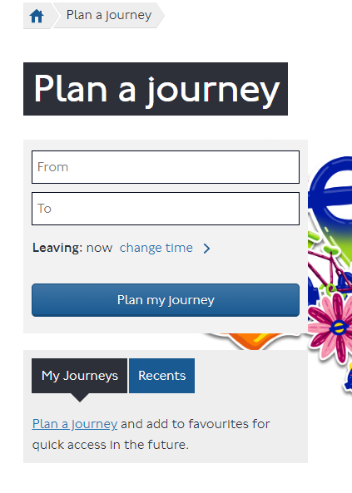

Scenarios

We would like you to build a UI automation framework to cater for some of the functionalities of the widget. The framework should contain a minimum of 5 tests which will verify the following:

- Verify that a valid journey can be planned using the widget from “Leicester Square Underground Station” to “Covent Garden Underground Station”. (Select value from auto complete suggestions do not enter the complete text)
  - Validate the result for both walking and cycling time.
- Once the journey is planned, “Edit preferences”, select routes with least walking, and update journey.
  - Validate the journey time
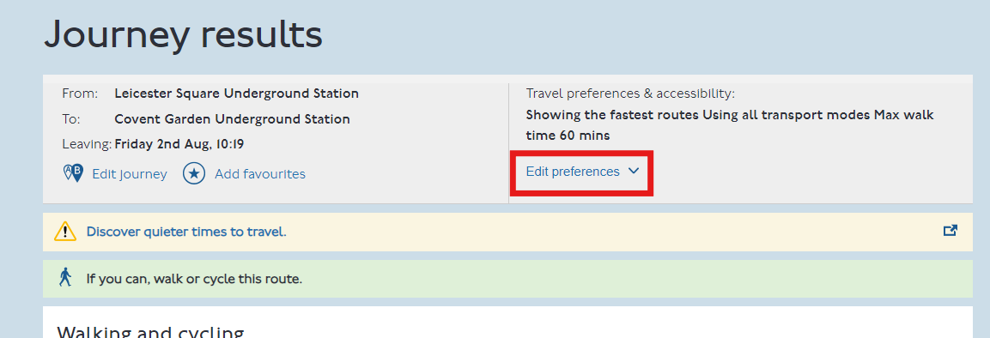
- Click on “View Details”
  - Verify complete access information at Covent Garden Underground Station
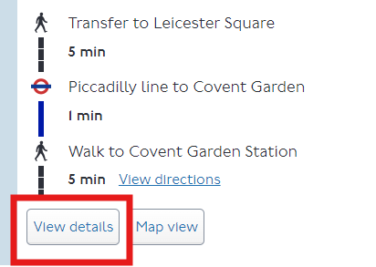
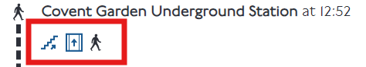
- Verify that the widget does not provide results when an invalid journey is planned. (An invalid journey will consist of 1 or more invalid locations entered into the widget).
- Verify that the widget is unable to plan a journey if no locations are entered into the widget.

Additional Scenarios
- Add few scenarios about what you would test, functional and non-functional, for this public facing component. (Do not write the automation tests, just listing the scenarios should be sufficient)

